Chapter 8 Rocks
extra worksheet 3: The rock cycle
Science understanding Logical/Mathematical
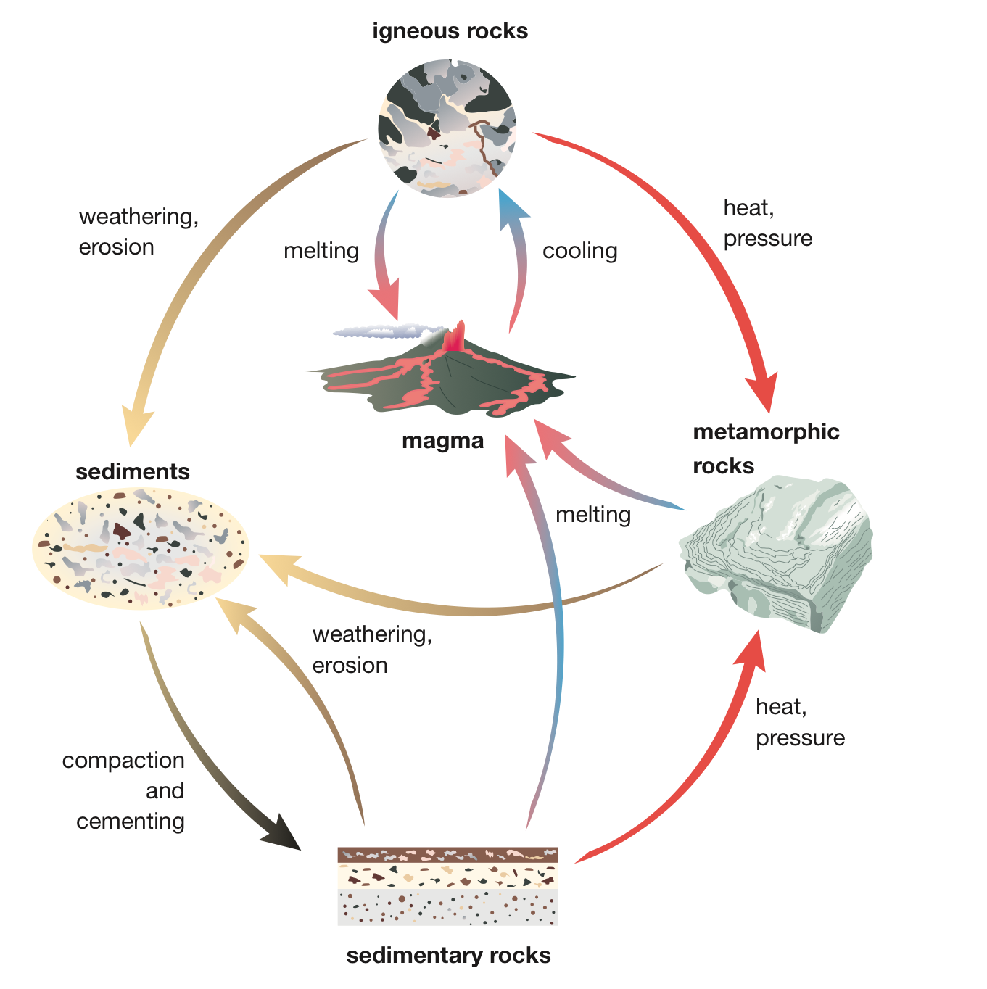
Figure 8.3.1 is a diagram of the rock cycle

Questions
1 Starting at magma in the diagram, identify which type of rock forms first, and the process by which it forms.

2 Once an igneous rock forms, explain how it can be recycled to become an igneous rock again.

3 Describe the processes that turn an igneous rock into a sedimentary rock.

4 Describe the processes that turn an igneous rock into a metamorphic rock.

5 Describe the processes that change metamorphic rocks into sedimentary rocks.

6 Describe the processes that change sedimentary rocks into metamorphic rocks.

7 Explain how a sedimentary rock can turn into an igneous rock.

8 Explain how the rock cycle is a useful model in geology.

